**Quadratic Equations:**

-uses if two numbers have a product of zero then at least once of the numbers must be zero

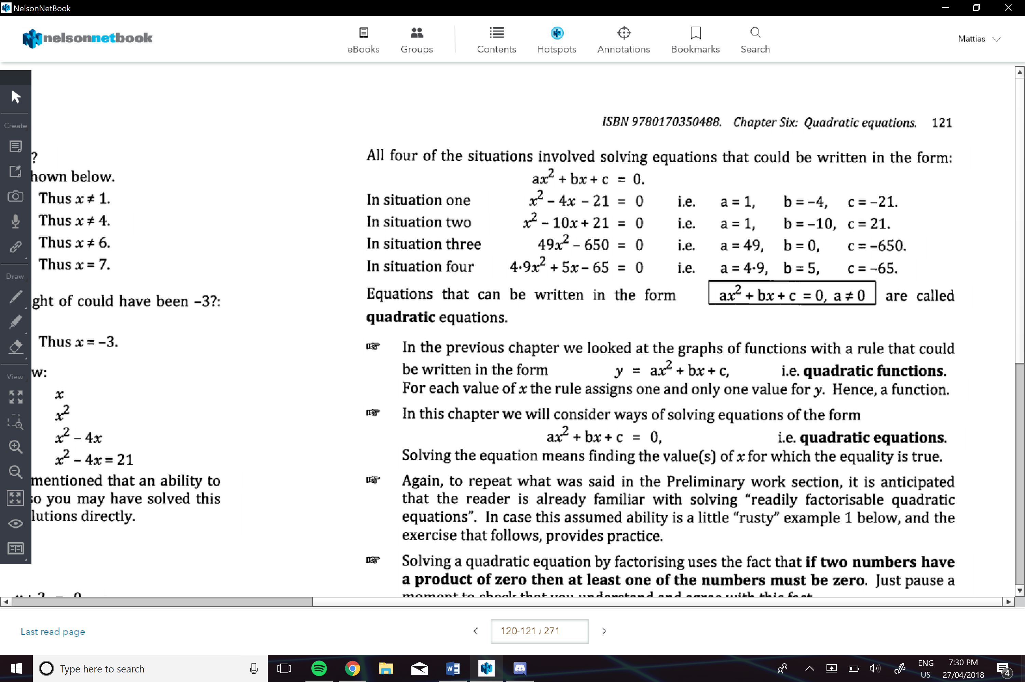

Don’t forget that a square root of a number can be positive or negative

e.g.

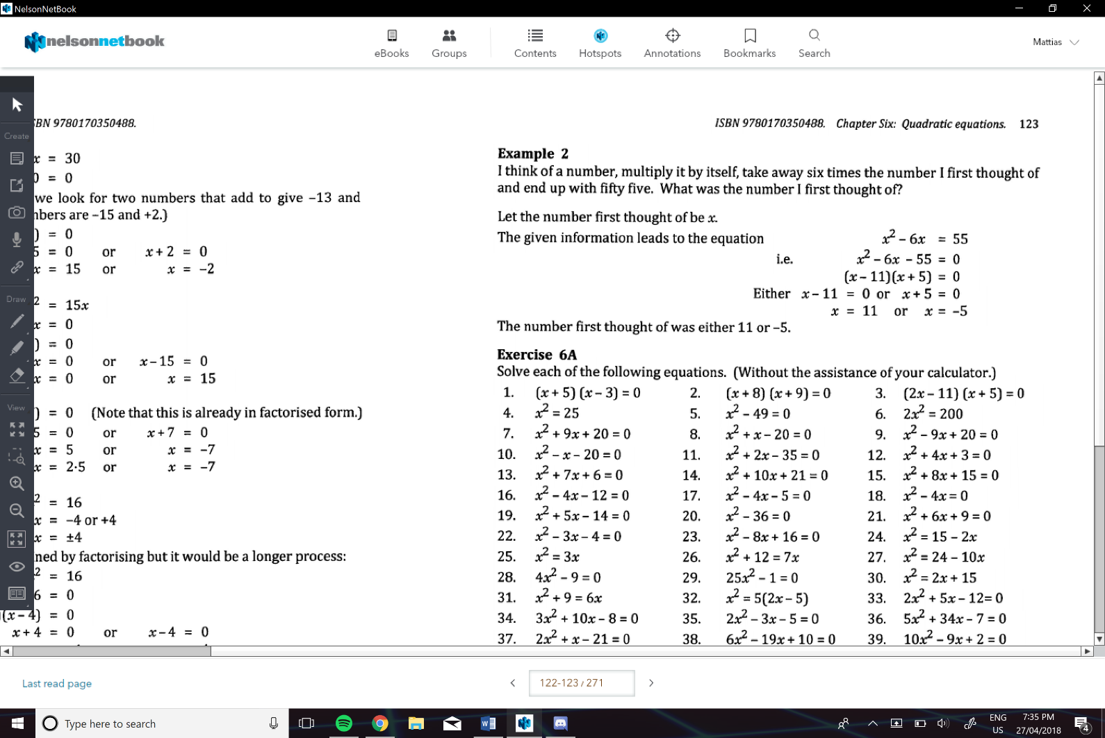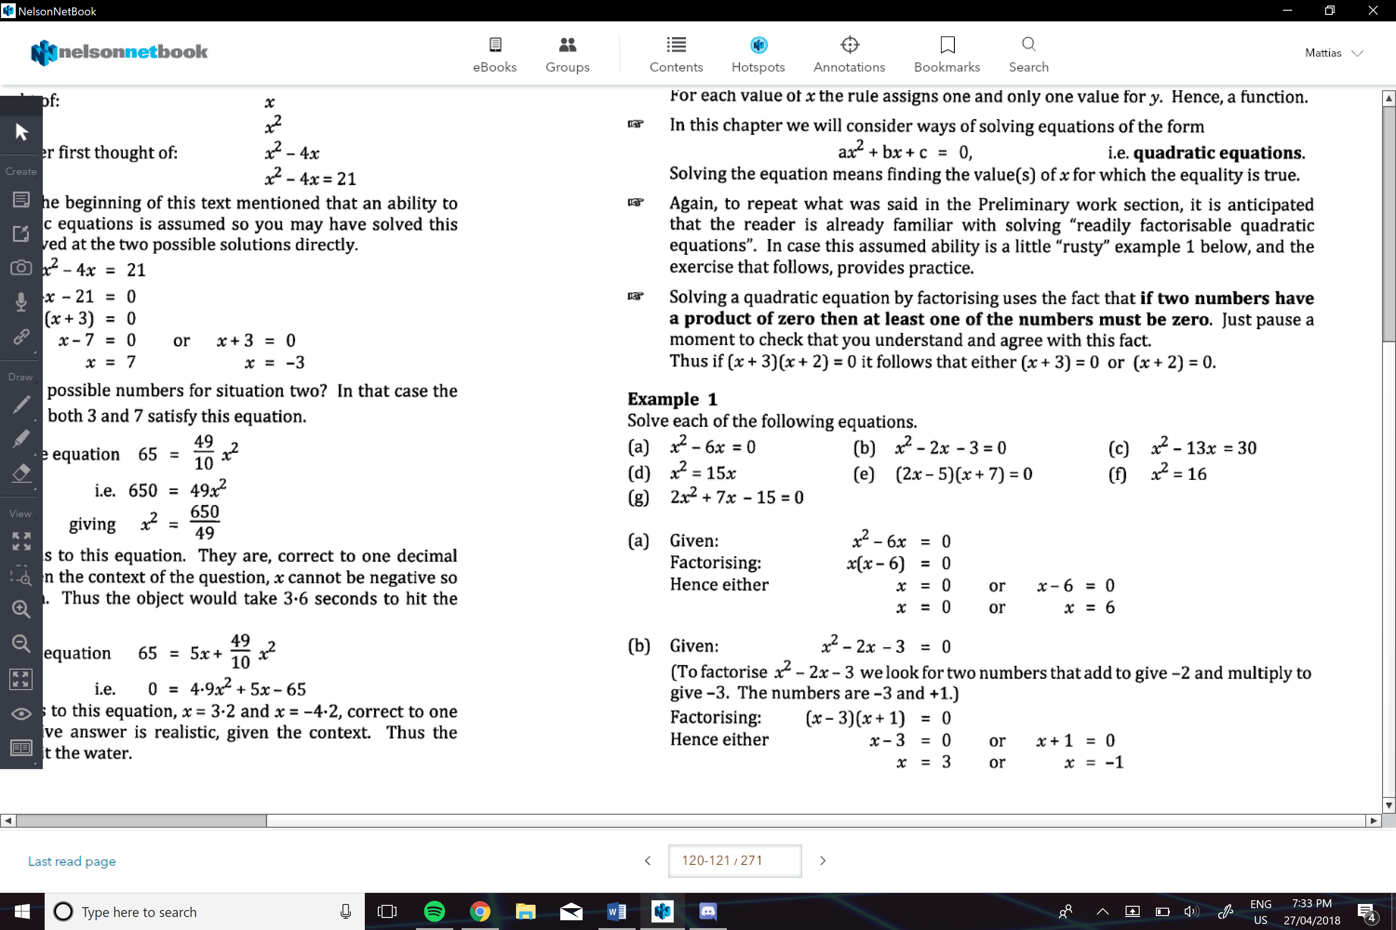

e.g.

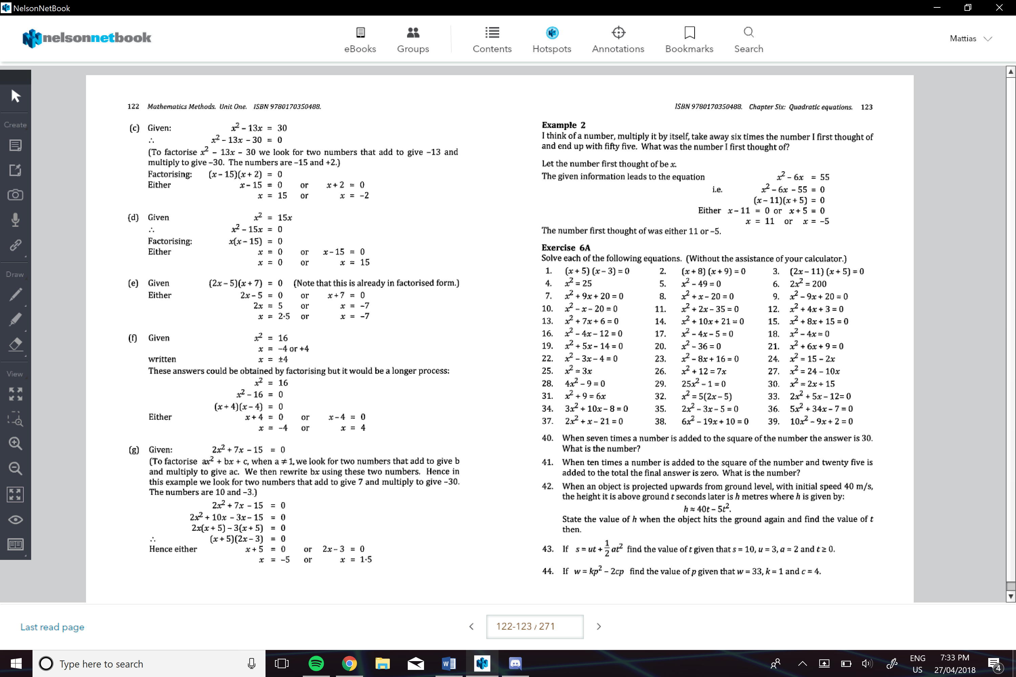

**When a quadratic equation is not really factorizable:**

We can:

* Use solve on the graphics calculator
* Sketch the graph, and then estimate the values of y and x
* Use *completing the square* technique
* Or use the formula

**Completing the Square Method:**

1. Move the c to the right-hand side
2. Add the square of half the coefficient of x to each side
3. Factorise LHS
4. Solve

e.g.

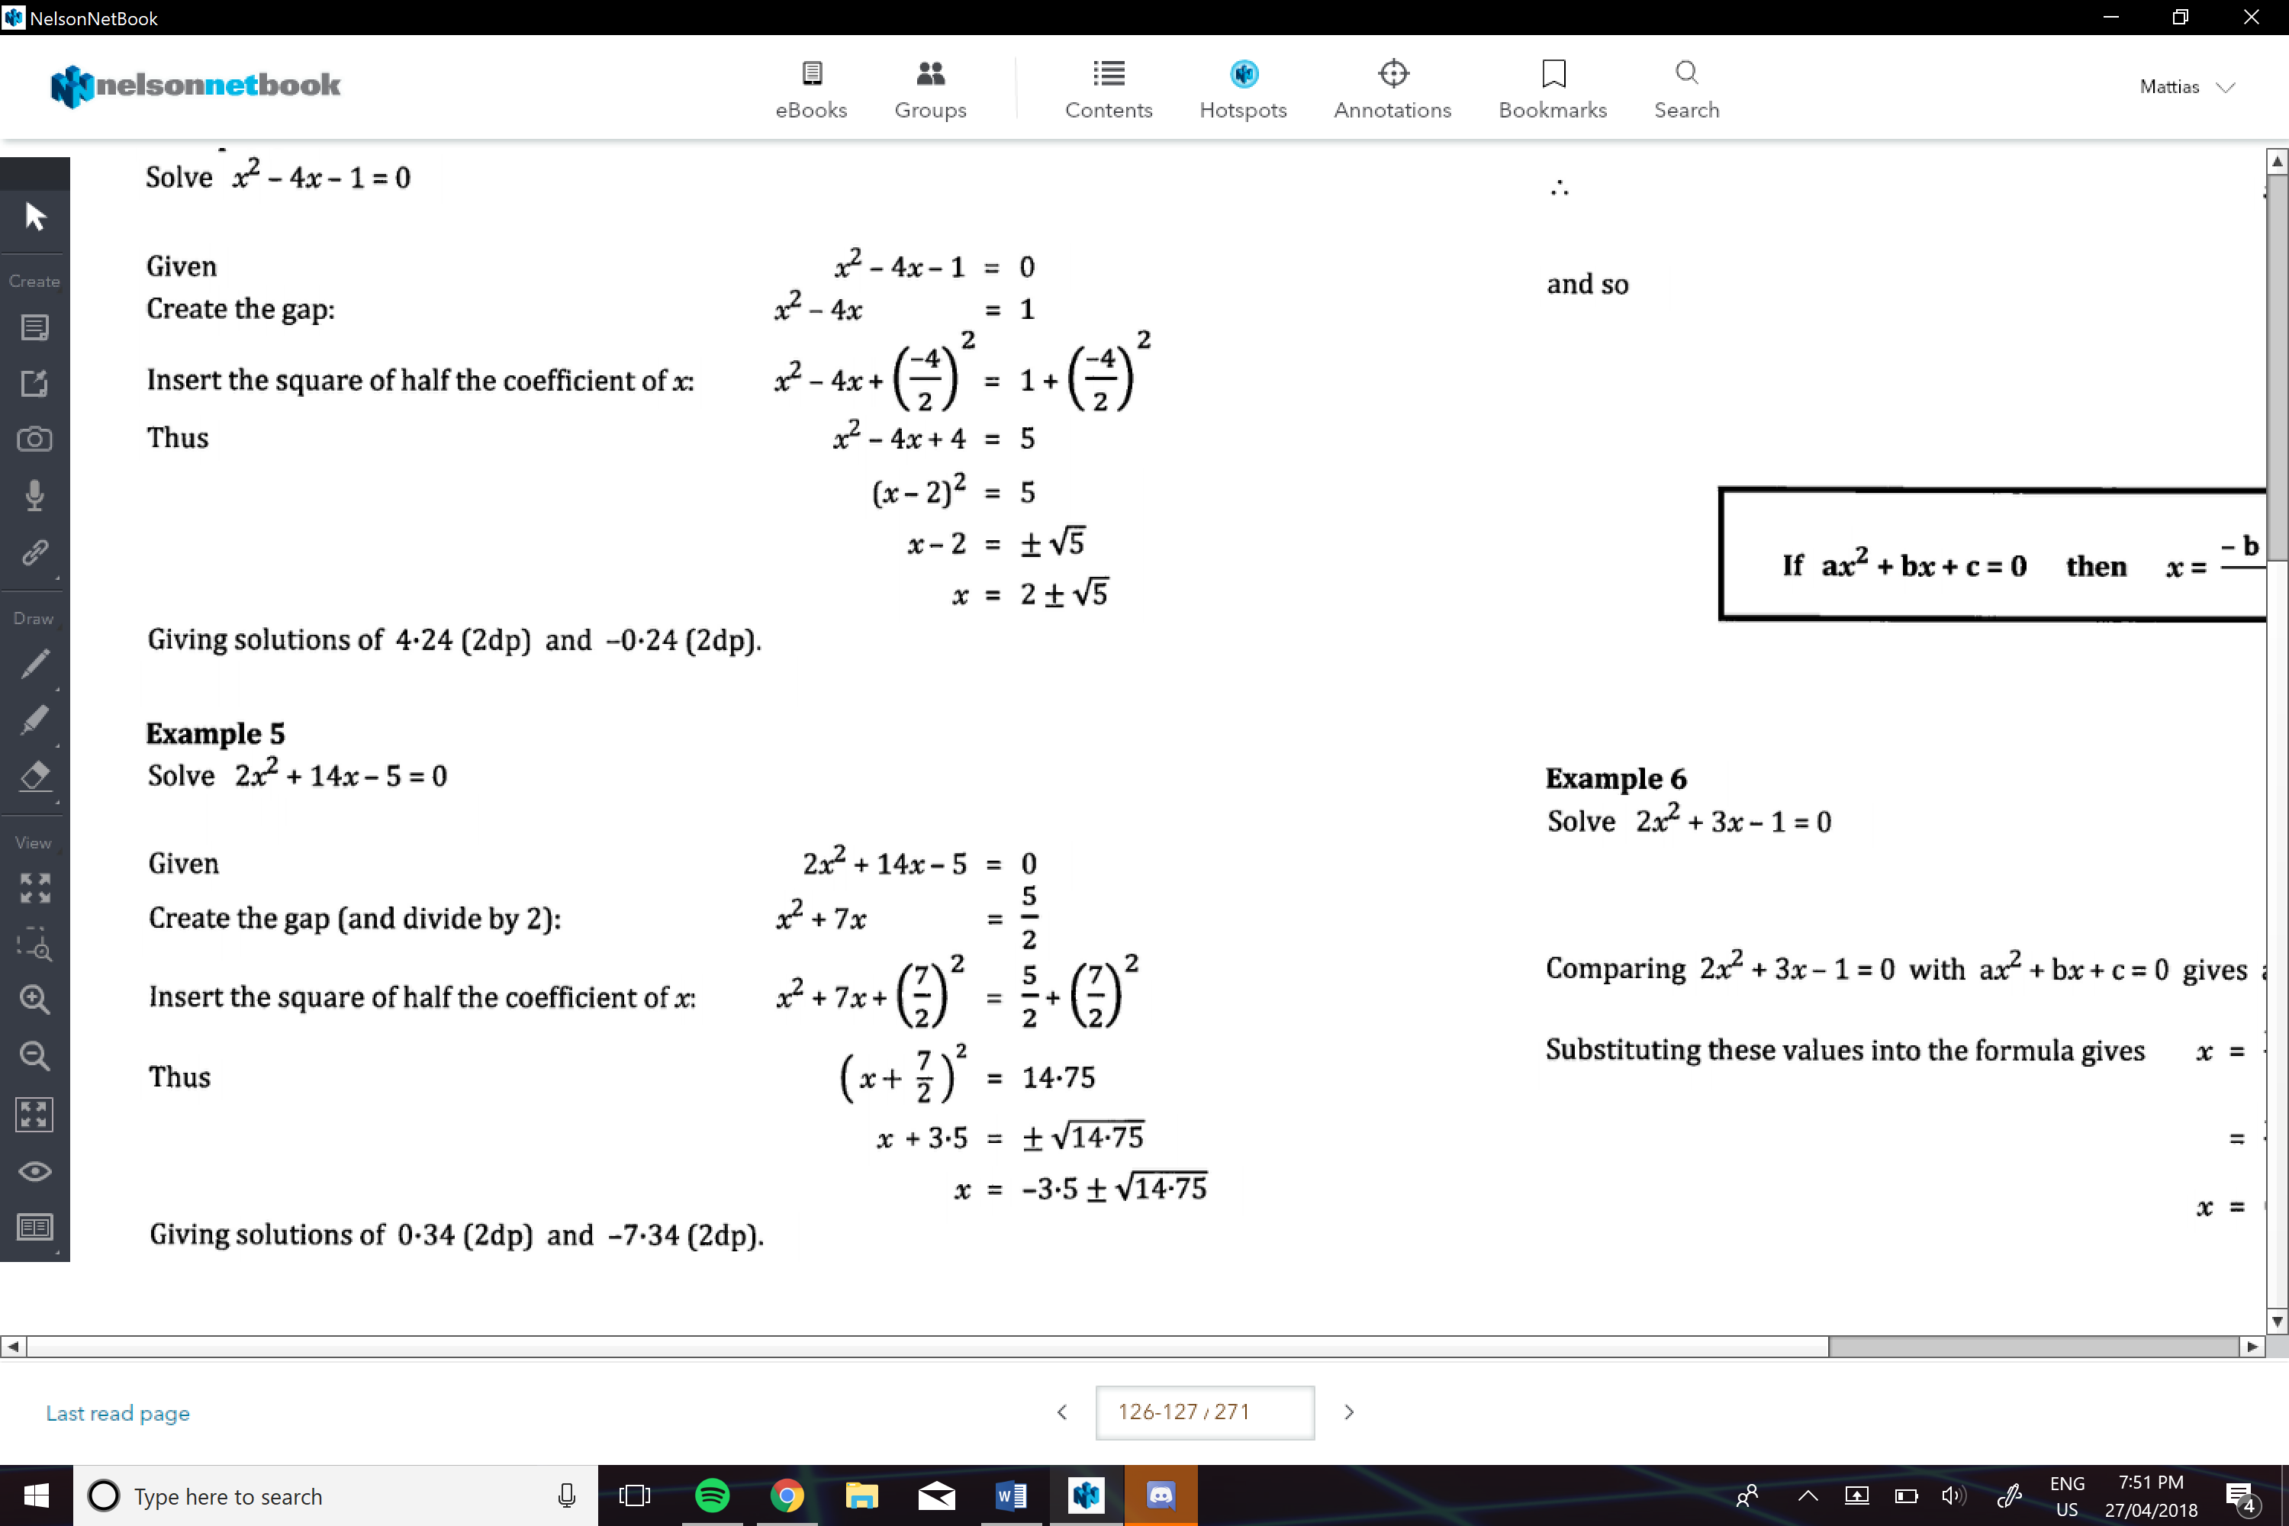

**Using the formula:**

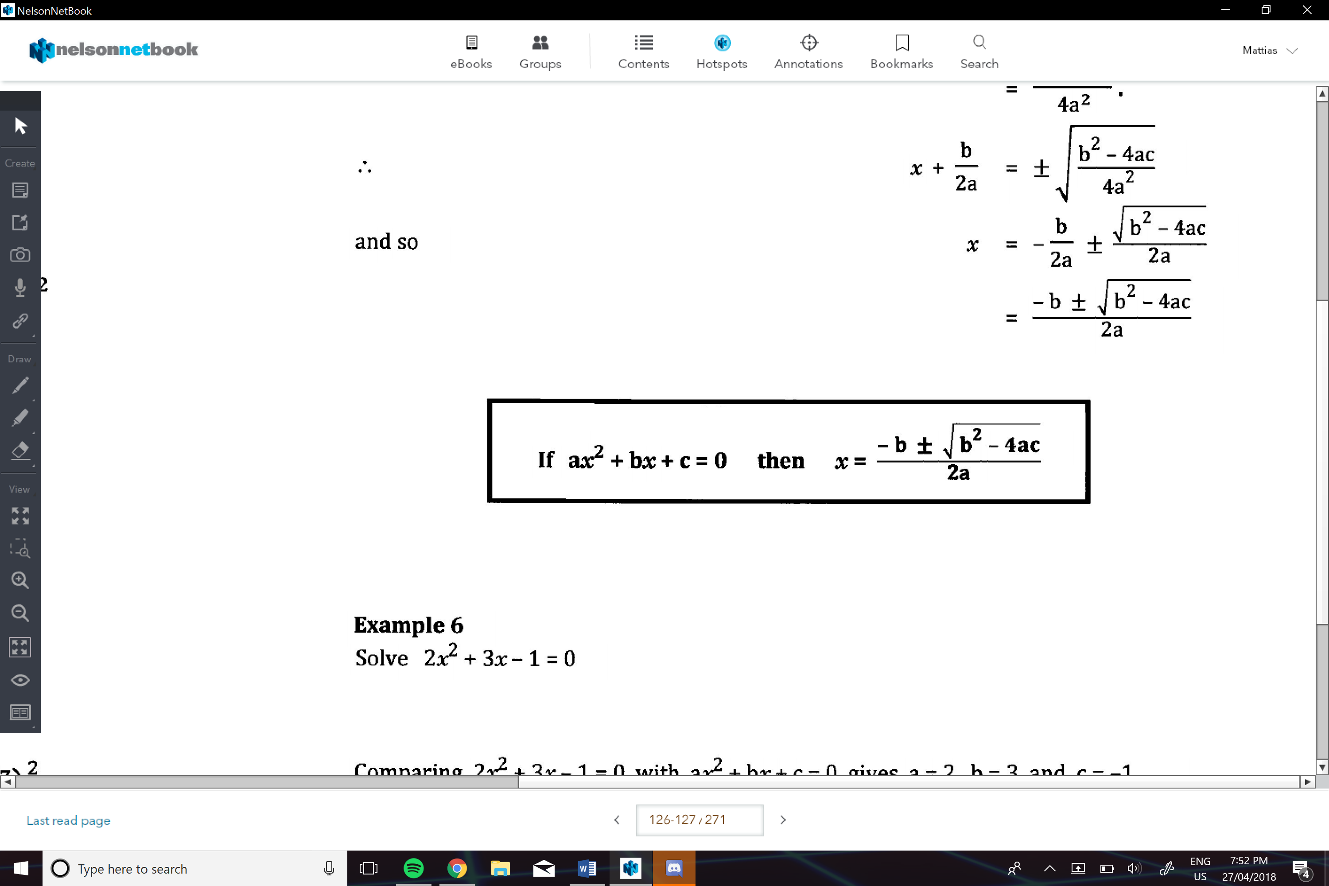

e.g.

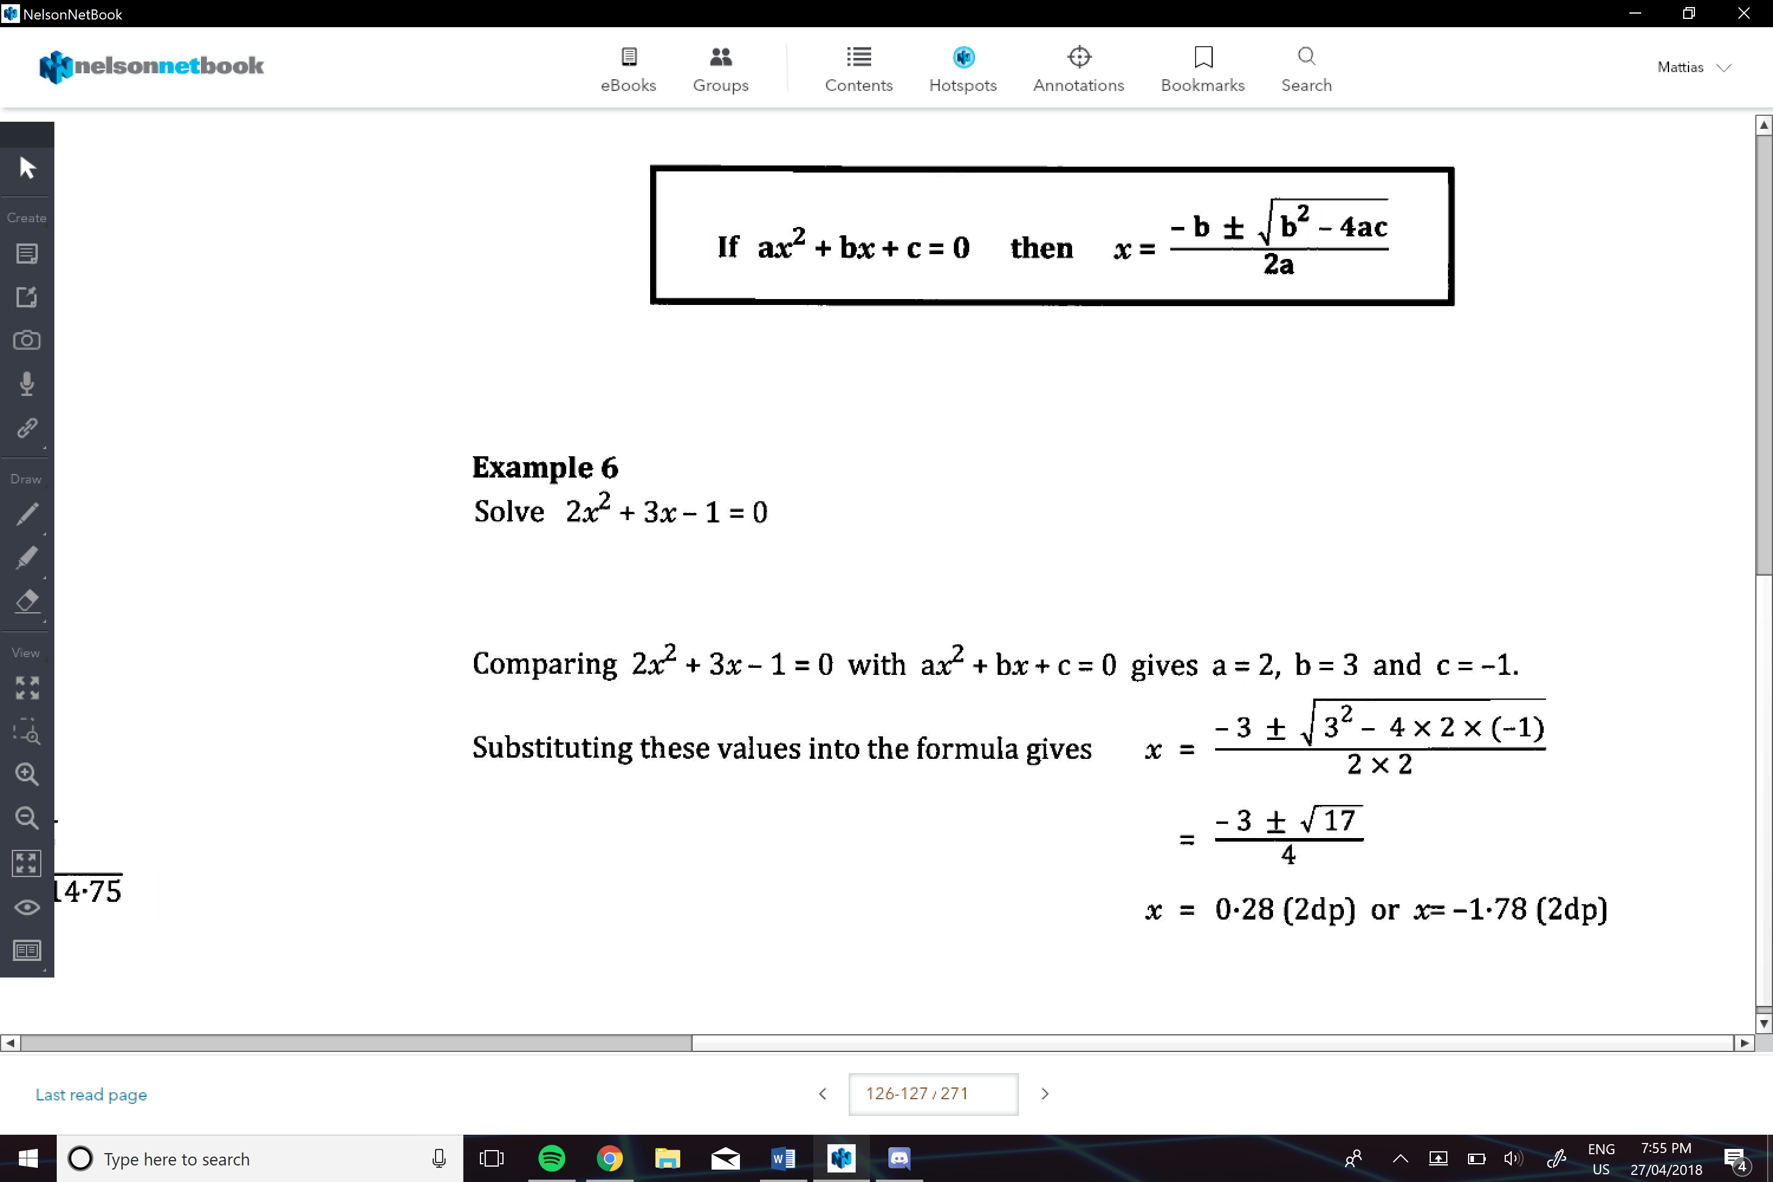

**Discriminant:(** ∆)

Use to find the number of solutions for x

